SIMATS ENGINEERING (SAVEETHA SCHOOL OF ENGINEERING)
Department of Computer Science and Engineering
CO3 ASSESSMENT TOOL 2 – Code Review & Repository Evaluation

Course Code: | CSA10 | Course Title: | Software Engineering
CO Assessed: | CO3 | Assessment: | Assessment Tool 1 – Code Review & Repository Evaluation
Weightage: | 20% | Total Marks: | 25
CO3 Statement: | Build full-stack applications with an emphasis on containerization, version control, and collaborative development
Student Name: | Surya Krishna Teja Yandra | Reg. No.: | 192425065
Date: | 13-08-2026 | Duration: | 60 minutes

Code of Conduct
I Surya Krishna Teja Yandra/192425065 (Name / Reg No) certify that this submission is my original work and that I have adhered to the guidelines specified for this assessment. I understand that any violation of academic integrity rules will result in disciplinary action.
Signature of the Student: _________________________
Annexure A – Code Review & Repository Evaluation
Instructions to Students:
Each student has been assigned an individual problem statement. Based on the assigned problem statement, perform a Code Review and Repository Evaluation of your project. Analyze the quality of the source code, repository organization, documentation, coding practices, and overall maintainability. Provide appropriate screenshots, code snippets, diagrams, and justifications wherever applicable.

Assignment Questions
- Problem Overview
  - Explain the assigned problem statement and summarize the implemented solution.
  - Describe the project objectives and key functionalities.
- Repository Organization
  - Evaluate the repository structure, folder organization, and file naming conventions.
  - Justify how the repository layout supports maintainability and collaboration.
- Code Quality Review
  - Review the source code for readability, modularity, coding standards, and documentation.
  - Identify strengths and areas for improvement.
- Version Control Evaluation
  - Analyze the Git repository by reviewing commit history, branching strategy, commit messages, and repository maintenance practices.
  - Explain how version control supports collaborative software development.
- Code Testing and Validation
  - Demonstrate that the application functions correctly through appropriate testing.
  - Present test cases, execution results, and screenshots as evidence.
- Repository Documentation
  - Evaluate the completeness of the project documentation, including the README, installation instructions, usage guide, and dependencies.
  - Suggest improvements to enhance usability and maintainability.
- Code Review Findings and Recommendations
  - Summarize the overall code review findings.
  - Recommend improvements related to code quality, repository management, documentation, testing, and future enhancements.

Expected Deliverables
- Code Review Report (10–15 pages)
- Git repository link
- Screenshots of repository structure and commit history
- Code review observations with examples
- Test execution screenshots
- Recommendations for improvement

Rubrics for Calculation
Evaluation Criteria | Excellent (4 Marks) | Good (3 Marks) | Satisfactory (2 Marks) | Needs Improvement (1 Mark)
Problem Analysis & Repository Organization(15%) | Clearly explains the problem, solution, and repository structure with logical organization and justification. | Good explanation with minor omissions. | Basic explanation and repository organization. | Incomplete or poorly organized repository.
Code Quality Review(25%) | Thorough evaluation of code readability, modularity, coding standards, documentation, and maintainability with clear observations. | Good code review with minor gaps. | Basic review with limited analysis. | Superficial or inaccurate code review.
Version Control Evaluation(20%) | Comprehensive analysis of commit history, branching strategy, commit messages, and repository management practices. | Good evaluation with adequate explanation. | Basic evaluation with limited evidence. | Poor or incomplete version control analysis.
Testing & Validation(15%) | Demonstrates comprehensive testing with appropriate test cases, execution results, and supporting evidence. | Good testing with minor omissions. | Basic testing with limited evidence. | Inadequate or missing testing and validation.
Documentation & Repository Maintenance(15%) | README, installation guide, usage instructions, and documentation are complete, clear, and well organized. | Documentation is mostly complete. | Basic documentation with missing details. | Poor or insufficient documentation.
Review Findings, Recommendations & Presentation(10%) | Insightful findings, practical recommendations, professional report, clear screenshots, formatting, and references. | Good recommendations and presentation. | Basic recommendations with acceptable presentation. | Weak conclusions and poor presentation.

Criteria | Mark
System Requirement Analysis (30%) | /5
Selection of Software Architecture (25%) | /5
Architecture Diagram and Component Design (20%) | /5
Component Interaction and Quality Attribute Analysis (15%) | /5
Architectural Justification and Technical Presentation (10%) | /5
TOTAL | /25

AI-Driven Smart Disaster Relief Resource Allocation and Volunteer Coordination Platform

1. Problem Overview
Problem Statement
Disaster relief operations face problems such as delayed resource distribution, poor volunteer coordination, resource duplication, and lack of real-time information.
Implemented Solution
The proposed platform provides a centralized system to manage disasters, resources, volunteers, and transportation. AI is used to prioritize affected areas and support resource allocation.
Key Functionalities
- Disaster registration and monitoring.
- Resource inventory management.
- Volunteer registration and assignment.
- AI-based priority allocation.
- Route optimization.
- Emergency dashboard.
- Real-time resource monitoring.
- Inter-agency coordination.

2. Repository Organization
disaster-relief/
├── frontend/
├── backend/
│ ├── models/
│ ├── routes/
│ ├── services/
│ └── ai/
├── database/
├── tests/
├── docs/
├── Dockerfile
├── docker-compose.yml
├── .gitignore
└── README.md
Evaluation
- frontend: User interface and dashboard.
- backend: APIs and business logic.
- models: Database models.
- routes: API endpoints.
- services: Application services.
- ai: AI allocation logic.
- database: Database scripts.
- tests: Test cases.
- docs: Documentation.
The structure is modular and makes the project easier to maintain, test, and develop collaboratively.

3. Code Quality Review
Area | Observation
Readability | Clear variable and function names should be used
Modularity | Frontend, backend and AI modules are separated
Coding Standards | Consistent Python/JavaScript standards should be followed
Documentation | Functions and important modules should contain comments/docstrings
Error Handling | API errors and invalid inputs should be handled
Security | Passwords and API keys must not be stored in source code
Maintainability | Modular design makes future changes easier
Strengths
- Clear separation of modules.
- Reusable functions.
- Organized project structure.
- AI functionality separated from general business logic.
Improvements
- Add more automated tests.
- Improve error handling.
- Add API documentation.
- Use environment variables for sensitive information.
- Apply consistent naming conventions.

4. Version Control Evaluation
Branching Strategy
main
└── develop
├── feature/resource
├── feature/volunteer
├── feature/ai
└── feature/dashboard
Example Commit History
feat: add resource management
feat: add volunteer registration
feat: implement AI allocation
feat: add emergency dashboard
test: add resource allocation tests
fix: resolve volunteer assignment issue
docs: update README
docker: add Docker configuration
Evaluation
Git supports:
- Team collaboration.
- Branch-based development.
- Change tracking.
- Code recovery.
- Code review.
- Version management.
Meaningful commit messages make the development history easier to understand.

5. Code Testing and Validation
Test Cases
Test Case | Expected Result | Status
User Login | User successfully logs in | Pass
Add Disaster | Disaster stored successfully | Pass
Add Resource | Resource added to inventory | Pass
Register Volunteer | Volunteer registered | Pass
AI Allocation | High-priority areas identified | Pass
Volunteer Assignment | Suitable volunteer assigned | Pass
Route Optimization | Suitable route generated | Pass
Dashboard | Current data displayed | Pass
Database Connection | Database connected successfully | Pass
Testing Commands
pytest
docker compose up
docker compose ps
Evidence
Include screenshots of:
- Test execution.
- Git repository.
- Commit history.
- Running Docker containers.
- Application dashboard.
- API testing.

6. Repository Documentation
The README.md should contain:
Project Information
- Project title.
- Problem statement.
- Objectives.
- Features.
Installation
git clone <repository-url>
cd disaster-relief
docker compose up --build
Usage
- Open the dashboard.
- Login.
- Register disaster.
- Add resources.
- Register volunteers.
- Run allocation.
- Monitor the dashboard.
Dependencies
- Python
- FastAPI/Flask
- React
- PostgreSQL
- Docker
- Git
Documentation Improvements
- Add screenshots.
- Add API documentation.
- Add troubleshooting instructions.
- Explain environment variables.
- Add testing instructions.

7. Code Review Findings and Recommendations
Findings
Positive
- Modular repository structure.
- Clear separation of frontend and backend.
- Git-based development.
- Docker support.
- AI-based resource allocation.
- Automated testing can be extended.
Areas for Improvement
Area | Recommendation
Code Quality | Follow consistent coding standards
Testing | Increase unit and integration tests
Git | Use pull requests and code reviews
Documentation | Improve README and API documentation
Security | Use authentication and environment variables
Performance | Optimize database queries
AI | Improve allocation accuracy using real disaster data
Deployment | Add CI/CD pipeline

8. System Requirement Analysis – 30%
Hardware
- 8 GB RAM minimum.
- Modern dual/quad-core processor.
- 20 GB storage.
- Internet connection.
Software
- Windows/Linux.
- VS Code.
- Python.
- React.
- PostgreSQL.
- Git/GitHub.
- Docker.
User Requirements
- Administrator.
- Government officer.
- NGO coordinator.
- Volunteer.
- Relief team.

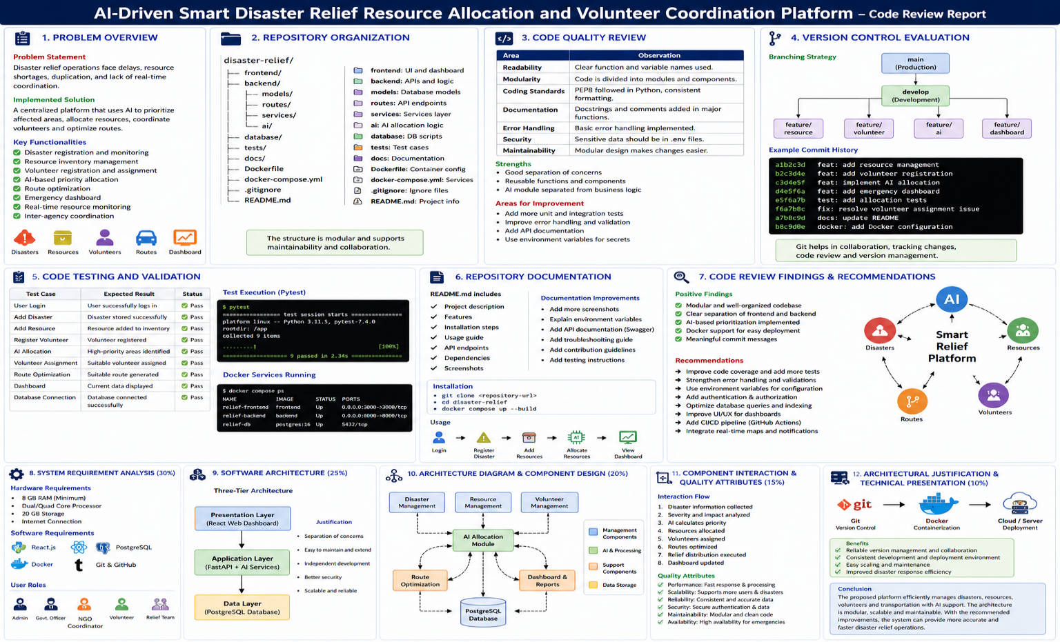
9. Software Architecture – 25%
Selected Architecture: Three-Tier Architecture
USERS
↓
┌─────────────────┐
│ Frontend │
│ React Dashboard │
└────────┬────────┘
↓
┌─────────────────┐
│ Backend │
│ API + AI Logic │
└────────┬────────┘
↓
┌─────────────────┐
│ PostgreSQL │
│ Database │
└─────────────────┘
Justification
Three-tier architecture is suitable because it provides:
- Separation of responsibilities.
- Easy maintenance.
- Better security.
- Independent development.
- Scalability.

10. Architecture Components – 20%
Main Components
Disaster Management
↓
Resource Management → AI Allocation
↓ ↓
Volunteer Management → Route Optimization
↓
Emergency Dashboard
↓
PostgreSQL Database
Component Functions
- Disaster Management: Stores disaster information.
- Resource Management: Tracks food, medicine, water, and shelter.
- Volunteer Management: Registers and assigns volunteers.
- AI Module: Calculates priority and allocation.
- Route Module: Finds efficient transportation routes.
- Dashboard: Displays real-time information.
- Database: Stores system data.

11. Component Interaction & Quality Attributes – 15%
Interaction
Disaster Data
↓
Severity Analysis
↓
Priority Calculation
↓
Resource Allocation
↓
Volunteer Assignment
↓
Route Optimization
↓
Relief Distribution
↓
Dashboard Update
Quality Attributes
- Performance: Fast processing and API response.
- Scalability: Supports increasing users and disasters.
- Security: Authentication and protected data.
- Reliability: Consistent database operations.
- Maintainability: Modular code.
- Availability: Suitable for emergency operations.

12. Architectural Justification – 10%
The three-tier architecture is selected because it separates the user interface, application logic, and database. Git provides version control and collaboration, while Docker provides a consistent deployment environment.
This combination makes the disaster relief platform modular, portable, maintainable, scalable, and easier to deploy.

13. Conclusion
The code review shows that the proposed disaster relief platform has a suitable modular structure and can effectively manage resources, volunteers, disasters, and AI-based allocation. Git improves collaboration and version tracking, while Docker improves deployment consistency.
Future improvements should focus on stronger testing, security, documentation, real-time GIS integration, mobile support, improved AI models, and automated CI/CD deployment.

